Lesson 6: Translating and Evaluating Expressions
GETTING YOURSELF READY
Materials:  Mini whiteboards  Index Cards  Student Handout photocopies  Answers to Guided Practice completed and photocopied  Answers to last night’s Independent Practice completed and photocopied  Misconception to New Understanding Sheets  Slips of paper |  | Your Preparation:  Put last night’s Independent Practice Answer Key and the Misconception to New Understanding Worksheet on a table for students to pick up on their way in to class. |  |  | Agenda with times:  Do Now and Purpose: 5 minutes  Key Vocabulary: 3 minutes  Building the Skill: 15 minutes  Structured Practice: 15 minutes  Guided Practice: 10 minutes  Closure: 2 minutes
GETTING YOUR STUDENTS READY
*Do Now:
Use the answers to last night’s homework problems to correct your homework problems. If you got a 100%, you may write 100% on the top and turn it in. If you got any wrong, you will need to record in your agenda book which problems you got wrong, and tonight, you will need to complete a Misconception to New Understanding for each problem you got wrong.

Complete the Do Now Handout.
Objective: Today you will be able to translate and evaluate expressions |  |  | Proving Behavior: By translating and evaluating expressions in word problems with 80% accuracy.
Purpose: In algebra, we are always asked to represent our solutions in simplest terms. We will have to be able to translate verbal expressions into algebraic expressions so that we can simplify them. Sometimes, we will have a variable expression that we have to simplify for different values.
Key Vocabulary: (from Glencoe.com)
Create vocabulary cards with these definitions and a picture to represent them and hang on the word wall. Use the cards to ask the students the given questions about the vocabulary and have them respond chorally or on their mini-whiteboards.
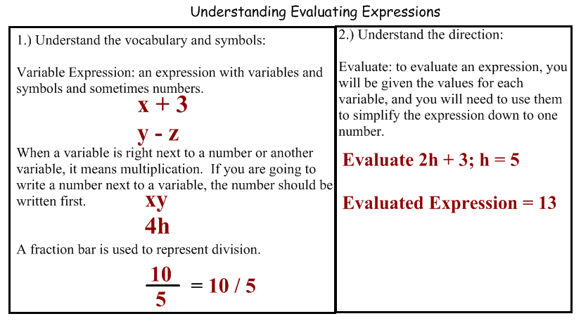
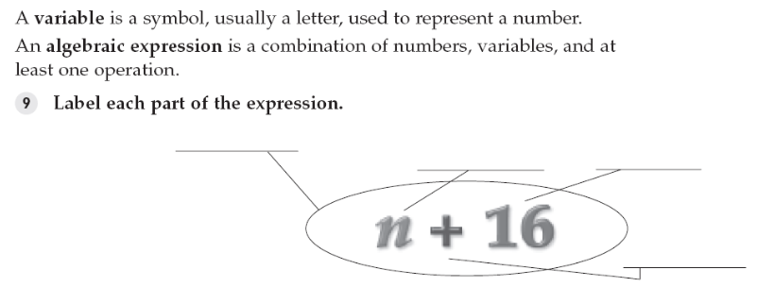
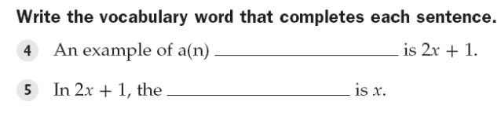

BUILDING THE SKILL
Evaluating Expressions | Say/See: Say and show each step of the VIP: Evaluating Expressions.  Do: After each step you say and show, have the students complete that step for number 14 using their mini whiteboards. After you complete the VIP, have the students complete 1-2 with a partner, 3-6 on their own, 7-8 with a partner, 9-12 on their own, 15-17 with a partner, 18-23 on their own as whiteboard drills.
Translating Expressions | Say/See: Say and show each step of the VIP: Translating Expressions. I’ll let the students come up with the words for sum, subtraction, etc. Instead of just saying it for them.  Do: After each step you say and show, have the students complete that step for problem 1 on their whiteboards. After the VIP, have the students complete 8 with a partner, 9-12 alone, 13-14 with a partner, and 15-18 alone as whiteboard drills.
PRACTICING THE SKILL
*Structured Practice
Time: 5 minutes  Materials: Word Problems  Group Size: Pairs  Materials: Mini Whiteboards | There are three sets of word problems for the Structured/Guided Practice. Have the students complete the first problem of each section, one at a time, with a partner and hold up their whiteboards for you to see their answer. Because they are word problems, require the students to use their strategy of visualizing. They should draw some picture to represent the problem before solving. If the students are proficient, they may go on and use the remaining problems as their Guided Practice. If they need more help, you may do a whole class think aloud or give them another problem in the section to complete with a partner before releasing them to Guided Practice.
*Guided Practice (the proving behavior of the objective monitored by teacher)
Assignment: Guided Practice Handout. Have the students complete the remainder of the word problems. Make sure they show their visualization for each problem. |  |  |  | Criteria for Mastery: 80% of the remaining problems.
Explain Homework: Independent Practice Handout. Only five problems – the rest are there for extra practice if necessary.
*Closure: On an index card, create one word problem that you feel would represent this lesson. On the back of the index card, solve the problem and make sure you show your visualization.

